Filename Time and Date Converter technical doc

Independent Studies

Jordan Nash

Student Experiments  Jnash51@live.com

Contents

1. Analysis 2

Introduction 3

Internal system overview 4

UI sketch 6

Algorithms 7

2. Design 8

Pseudo Code 9

Use Case Diagram 11

Languages that support our program: 12

# Analysis

## Introduction

Our program in development will be called the Filename Time and Date Converter (FTDC.) It’ll allow conversion of original metadata of selected files into ones that match the property’s Time and Date.

Immediately following conversion. Files with the matching date will be stored into a new folder that matches the date of those files.

## Planning the program

The FTDC might not be able to be done properly yet at our level. But we could potentially get the first stage of it done which will involve conversion of file names to match it’s time and date of existence.

For example:

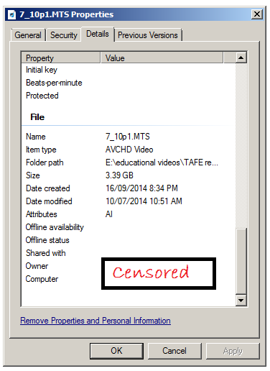

It will require conversion of file names. We may have to map the time and date properties as file names. Based on the Algorithms, I feel we should make use of C#. We may need a basic understanding of XML. This obviously implies that we should already do this on a Windows OS, even though we already have it.

## Functionality required:

* A string for the Filename.
* A filename read method to read the currently selected filename.
* A copy method to make a copy of the selected filename.
* A filename writer method to write to new filename (date time) as the file name argument.
* Event to check if user dragged file into ListView.
* Event to check if user dropped file into ListView.

## Components required:

* One button to convert the file names in drag and dropbox to it’s date and time and assign each of them to the folder path entered into the textbox.

OPTIONAL: put the videos in the selected folder path, packaging them into a folder with the matching date in a folder written with time and date.

* One text box for inserting the folder path that the files will be copied to.
* One drag and drop box for the currently selected files to be stored in memory ready for conversion.

**2. Design**

## UI sketch

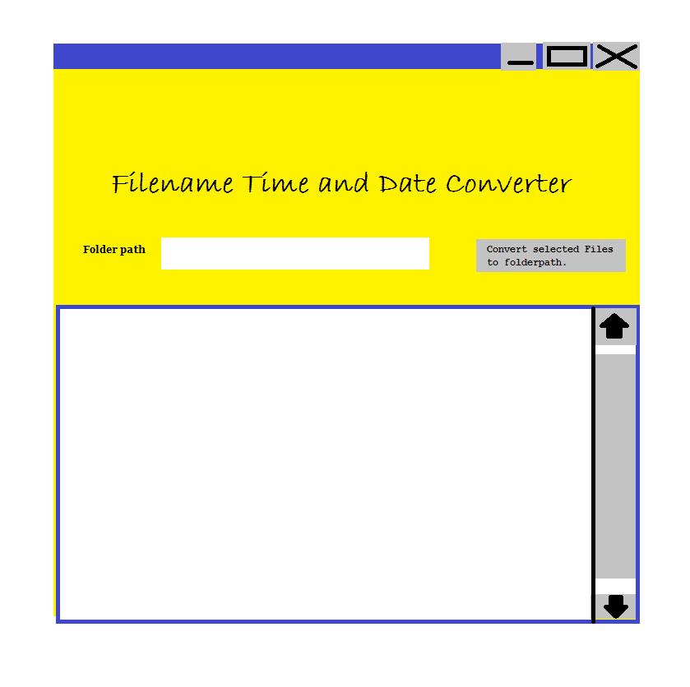

A textbox that allows insertion of folder path that file will be written to.

A button to allow conversion and assign it to folder path.

A drag and drop box that displays all selected files, ready for conversion.

## Algorithms

**//Problem#1:** To allow conversion of original metadata of selected files into ones that contain in this date order YYYY MM DD, & the time in this order hh mm ss.

**//START**

//GET files in drag and drop box

//READ folder path.

//IF Folder path is equal to null

//Cancel operation.

//Message box “please enter folder path”

//END IF

//Get file’s property date and time

//Store it in RAM

//WHILE the current file needs converting:

//Convert selected file’s mettadata to match Property’s date and time.

//Write it to storage.

//END WHILE

**END**

**Problem#2:** To store videos with the matching date into a new folder that matches the date of those videos.

**START**

Store folder package in RAM

Get file’s property date

FOR the converted file is equal to the 1 designated folder’s date

Embed folder with designated file’s property date

Create folder

IF file is equal to the folder’s date

Pack file in folder.

END IF

END FOR

**END**

**Problem:** If the user defined folder path in textbox does not contain “/”.

**START**

//IF txtFolderPath text ends without “\”.

//GET Path.

//APPEND “\” to end of Path.

//ASSIGN Path to txtFolderPath text.

**END**

//PROBLEM: Output file does not display extension. Have to find program to reveal file. To write all files to target folder with extensions.

//RESEARCH methods involved with that.

//PLAY with source code.

//IMPLEMENT libraries that solve our problem.

## Pseudo Code

**START**

**CLASS** frmFTDC

**PRIVATE METHOD** DragDropBox()

GET File instance

WHILE File is greater than the total Files in DragDropBox

Store file in RAM

END WHILE

**PRIVATE METHOD** FolderPath ()

FolderPath assigned to fp.

GET fp.

IF fp is equal to null.

Then display message “Please enter folder path.”

END IF

**PRIVATE METHOD** ConvertFilename (DragDropBox, FolderPath)

INSTANTIATE file variable as object

GET File property (DateModified “value”).

Store the Filename in RAM

WHILE the current Filename doesn’t match DateModified

WRITE DateModified’s value in FileName as (DD)“_”(MM)”_”(YY)”_”(hh)+(mm).

STORE File in directory.

END WHILE.

**PRIVATE METHOD** PutFilesInEmptyFolder (FolderPath, Filename)

Enable auto folder creation

Get converted filename’s(DateModified “value”)

Make empty folder array

FOR the converted filename is not equal to the 1 designated Empty Folder

Pull empty folder from array.

Write folder name with the filename value as (DD”_(YY”_”(MM)))

If another converted file’s DateModified’s property is equal to the folder name.

Put file in folder

Chuck folder to storage

END IF

END FOR

**END**

## Use Case Diagram

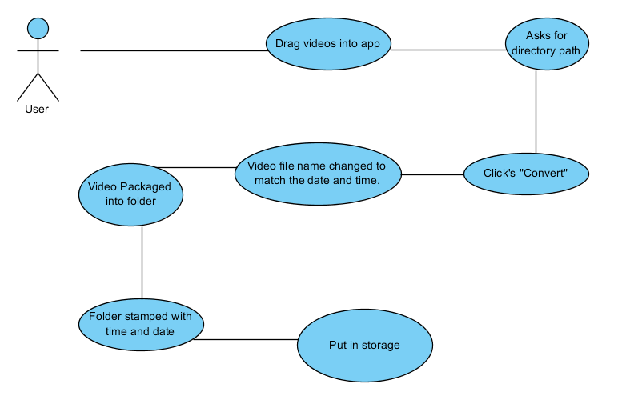

# 

## The language we’ll be using for our program:

We’re going right ahead and using C# Visual Studio. It allows [rewrite](Design/FileRenaming/C#_FileRename.pdf) of file names using a system package. This guy from a MSDN form gave people a tutorial for drag and dropping files in something called List Box. We may have already used such a thing for Alan Jovellanos’s Mr Sparkly ICAPRG406A.

Lastly it will have a [method for creating folders](Design/CreatingFolderPath/Directory.CreateDirectory%20Method%20(String,%20DirectorySecurity)%20(System.pdf) which is a real substitute for the FSO. Usually we’d contrast the language we’re using to others, but we don’t have time and I consider it overkill for such a small scale experiment. Java would be an ok alternative.